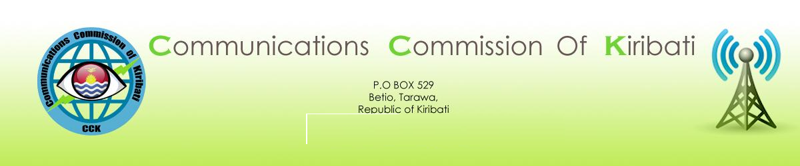
PUBLIC NOTICE
TO CONDUCT A CONSULTATION ON
THE COMMUNICATION COMMISSION OF KIRIBATI’S
PROPOSED RULES FOR LICENSING COMMUNICATIONS NETWORKS AND SERVICES
In accordance with Section 31 of the Communications Act of 2012, the Communications Commission of Kiribati (CCK) shall conduct a public consultation before making licensing rules for communications networks or services. Accordingly, the CCK gives notice that it has initiated a consultation process during which interested parties may submit their comments regarding its draft proposal for Rules for Licensing Communications Networks or Services.
The Communications Act of 2012 provides for a liberalized communications market. With this in mind, the CCK is developing a regulatory framework that is intended to offer incentives for individuals, businesses, and organizations to provide new communications network and services and thus create more choices for consumers and promote the socio-economic development of Kiribati.
The purpose of these rules is to:
- Promote entry by new licensees through a transparent, simple application process and low application and license fees. For example, the application fees range from zero for Internet Café services to AUD 250 for calling card and Internet services to a maximum of AUD 1,500 for a mobile cellular license. License fees have also been kept to a minimum with the average yearly charge of 1.5% of annual gross revenues. A complete list of license application and annual fees can be found in Schedule 2 of the draft licensing Rules;
- Foster investment and innovation in communications networks and the supply of communications services. The CCK encourages individuals and businesses to apply for licenses to provide cellular mobile, fixed line, network, satellite, gateway and exchange, resale, Internet services and any other service that a person is qualified and capable of providing. Licensees are free to select the most appropriate technology for their services, based on their own commercial decisions, subject to type approval, resource limitations, physical constraints, and public interest concerns if any;
- Provide incentives for new and existing licensed service providers to provide services to the Outer Islands of Kiribati. The draft rules propose lower annual license fees based on national geographic coverage for cellular mobile service providers and a zero annual license fee for the first 5 years of operation for independent, local operators who provide fixed line or mobile cellular services in the Outer Islands. A Licensee who provides public communications services in the Outer Islands may also be eligible for any designated subsidies and/or other assistance that becomes available as a result of the establishment of a Universal Access Fund.
For more information regarding CCK’s draft licensing rules, please visit the CCK website at www.cck.ki.
Stakeholders are encouraged to comment on any aspect of the draft rules. Responses should be in writing and include the name of the person or company/institution/association and their contact details, including email address if applicable. In the interest of transparency, CCK will publish all written responses to this consultation on its website, subject to the confidentiality of any information that the respondent has marked as confidential.
Once the CCK has considered any responses received, it will issue a final version of the rules, which shall be published on its website. The deadline for the receipt of responses is 27 February 2014 at 4:15 p.m. local time. Responses can be submitted to the CCK by:
- Email: consult@cck.ki
- Post: P.O. Box 529, Betio, Tarawa, Republic of Kiribati
- In person at the offices of CCK located in back of the Ministry of Communications, Transport, and Tourism Development in Betio.

